***Section* 1.7 – Physical Applications**

***Density and Mass***

Density is the concentration of mass in an object and is usually measured in units of mass per volume. An object with uniform density satisfies the basic relationship



When density of an object varies, this formula no longer holds, and we must appeal to calculus.

***Definition***

Suppose a thin bar or wire can be represented as a line segment on the interval  with a density function *ρ* (with units of mass per length). The mass of the object is



***Example***

A thin 2-*m* bar, represented by the interval , is made of any alloy whose density in units of *kg/m* is given by . What is the mass of the bar?

***Solution***









***Work* Done By a Constant Force**

When a body moves a distance *d* along a straight line as a result of being acted on by a force of constant magnitude ***F*** in the direction of motion, we define the ***work*** *W* done by the force on the body with the formula



 **(*Constant-force formula for work*)**

The unit of work is a newton-meter (***N.m***), also called ***joule***.

***Definition***

The work done by a variable force  in the direction of motion along the *x-*axis from *x* = *a* to *x* = *b* is



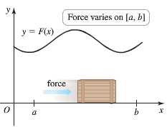

**Hooke’s Law for Springs: *F* = *kx***

***Hooke’s Law*** says that the force required to hold a stretched or compressed spring *x* units from its natural (unstressed) length is proportional to *x*. In symbols



The constant *k*, measured in force units per unit length, is a characteristic of the spring, called ***the force constant*** (or ***spring constant***) of the spring.

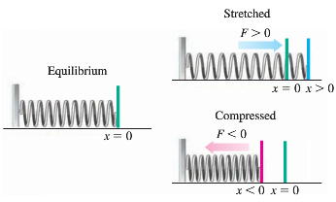 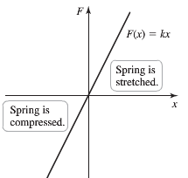

* To stretch the spring to a position , a force  (in the positive direction) is required.
* To compress the spring to a position , a force  (in the negative direction) is required.

***Example***

Find the work required to compress a spring from its natural length of 1 *ft* to a length of 0.75 *ft* if the force constant is *k* = 16 *lb./ft*.

***Solution***

 













***Example***

A spring has a natural length of 1 *m*. A force of 24 *N* holds the spring stretched to a total length of 1.8 *m*.

1. Find the force constant *k*.
2. How much work will it take to stretch the spring 2 *m* beyond its natural length?
3. How far will a 45-*N* force stretch the spring?

***Solution***

1. 









1. 









1. 



***Example***

A 5-*lb* bucket is lifted from the ground into the air by pulling in 20 *feet* of rope at a constant speed. The rope weighs 0.08 *lb/ft*. How much work was spent lifting the bucket and rope?

***Solution***

Work done on lifting the bucket only is:

*weight* x *distance* = 5 (20) = 100 *ft-lb*

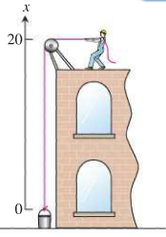Work on the rope:









The total work for the bucket and the rope combined is:

100 + 16 

**Lifting**

Another common work problem arises when the motion is vertical and the force is the gravitational force.

The gravitational force exerted on an object with a mass of *m* is , where  is the acceleration due the gravity near the surface of Earth.

The work in joules required to lift an object of mass *m* a vertical distance of *y* meters is



This type of problem leads to 3 key observation to the solution:

* Water from different levels of the tank is lifted different vertical distances, requiring different amounts of work,
* Water from the same horizontal plane is lifted the same distance, requiring the same amount of work.
* A volume *V* of water has mass , where  is the density of water.

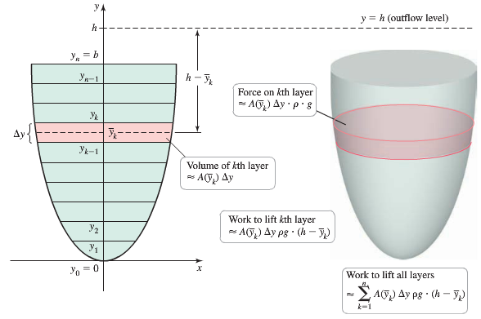

 ⇒ 







**Solving Lifting Problems**

1. Draw a  in the vertical direction (parallel to gravity) and choose a convenient origin. Assume the interval  corresponds to the vertical extent of the fluid.
2. For , find the cross-sectional area  of the horizontal slices and the distance  the slices must be lifted.
3. The work required to lift the water is



***Example***

The conical tank is filled to within 2 *feet* of the top with olive oil weighing 57 . How much work does it take to pump the oil to the rim of the tank?

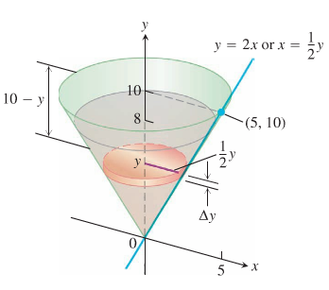

***Solution***

The volume of a slab between the planes *y* and Δ*y*:







The force  required to lift this slab is equal to its weight





Distance to lift to the level of the rim of the cone is about (10 – *y*) *feet,* so the work done lifting the slab

















**Pressure and Force**

Dams are built thicker at the bottom than at the top because the pressure against them increases with depth

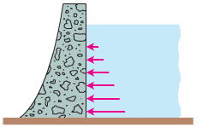

Pressure is a force per unit area, measured in units such as .

For example, the pressure of the atmosphere on the surface of Earth is about  

Another example, if you stood on the bottom of a swimming pool, you would feel pressure due to the weight (force) of the column of water above your head. If your head is flat and has surface area  and it is *h* meters below the surface, then the column of water above your head has volume . That column of water exerts a force:



Where *ρ* is the density of water

*g* is the acceleration due to gravity.

Therefore, the pressure on your head is the force divided by the surface area of your head



This pressure is called ***hydrostatic pressure*** (meaning the pressure of water at rest), and it has the following important property: it has the same magnitude in all directions.

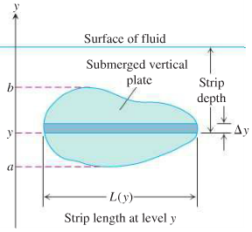Suppose that a plate submerge vertically in fluid of weight-density *w* runs from *y* = *a*  to *y = b* on the *y*-axis. Let  be the ***length*** (or ***width***) of the horizontal strip measured from left to right along the surface of the plate at level *y*. Then the force exerted by the fluid against one side of the plate is



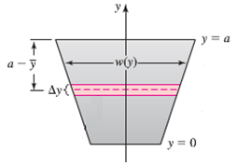**Solving Force / Pressure Problems**

1. Draw a  on the face of the dam in the vertical direction and choose a convenient origin (often taken to be the base of the dam).
2. Find the width function  for each value of *y* on the face of the dam
3. If the base of the dam is at  and the top of the dam is at , then the total force on the dam is



***Example***

A flat isosceles right-triangular plate with base 6 *feet* and height 3 *feet* is submerged vertically, base up, 2 *feet* below the surface of a swimming pool. Find the force exerted by the water against on side of the plate. (Freshwater Weight density: 62.4 )

***Solution***

The width of a thin strip at level *y* is: 

The depth of the strip beneath the surface is: 



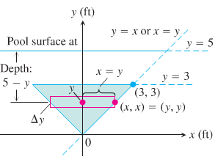 















***Example***

A cylindrical tank with a length of 10 *m* and radius of 5 *m* is on its side and half-full of gasoline. How much work is required to empty the tank through an outlet pipe at the top of the tank?

The density of gasoline is .

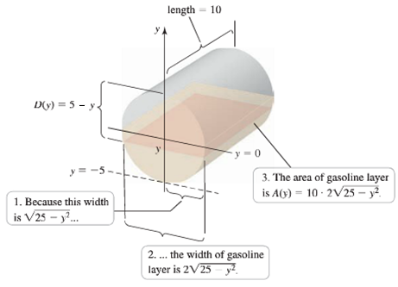***Solution***





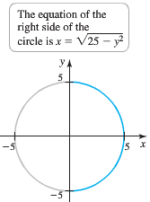













|  |  |  |
| --- | --- | --- |
| ***Material*** | ***Weight Density*** | |
|  |  |
| Aluminum | 2700 | 169 |
| Copper | 8940 | 558 |
| Freshwater | 1000 | 62.4 |
| Gasoline | 720 | 42 − 45 |
| Gold | 19320 | 1206 |
| Iron | 7870 | 491 |
| Lead | 11.34 | 708 |
| Magnesium | 1740 | 109 |
| Mercury | 13546 | 849 |
| Milk | 1030 | 64.5 |
| Molasses | 1600 | 100 |
| Olive Oil | 913 | 57 |
| Platinum | 21.45 | 1340 |
| Seawater | 1030 | 64 |

***Exercises*** ***Section* 1.7 – Physical Applications**

Find the mass of a thin bar with the given density function

|  |  |
| --- | --- |
|  |  |

1. Find the mass of a bar on the interval  with a density (in *g/cm*) given by 
2. Find the mass of a 3-*m* bar on the interval  with a density (in *g/m*) given by 
3. Find the mass of a bar on the interval  with a density



1. It takes 50 *J* of work to stretch a spring 0.2 *m* from its equilibrium position. How much work is needed to stretch it an additional 0.5 *m*?
2. It takes 50 *N* of force to stretch a spring 0.2 *m* from its equilibrium position. How much work is needed to stretch it an additional 0.5 *m*?
3. A cylindrical water tank has a height of 6 *m* and a radius of 4 *m*. how much work is required to empty the full tank by pumping the water to an outflow pipe at the top of the tank?
4. Find the total force on the face of a semicircular dam with a radius of 20 *m* when its reservoir is full of water. The diameter of the semicircle is the top of the dam.
5. A rock climber is about to haul up 100 *N* (about 22.5 *lb.*) of equipment that has been hanging beneath her on 40 *m* rope that weighs 0.8 *N/m*. How much work will it take? (*Hint*: Solve for the rope and equipment separately, then add)
6. A 2-oz tennis ball was served at . How much work was done on the ball to make it go this fast? (to find the ball’s mass from its weight, express the weight in pounds and divide by , the acceleration of gravity.)
7. How many foot-pounds of work does it take to throw a baseball 90 *mph*? A baseball weights 5 *oz*.
8. A 1.6-*oz* golf ball is driven off the tee at a speed of . How many foot-pounds of work are done on the ball getting it into the air?
9. You drove an 800-*gal* tank truck of water from the base of a mountain to the summit and discovered on arrival that the tank was only half full. You started with a full tank, climbed at a steady rate, and accomplished the 4750-*ft* elevation change in 50 *min*. Assuming that the water leaked out at a steady rate, how much work was spent in carrying water to the top? Do not count the work done in getting yourself and the truck there. Water weighs 8 *lb/gal*.
10. A force of 200 *N* will stretch a garage door spring 0.8 *m* beyond its unstressed strength. How far will a 300-*N* force stretch the spring? How much work does it take to stretch the spring this far from its unstressed length?
11. A heavy-duty shock absorber is compressed 2 *cm* from its equilibrium position by a mass of 500 *kg*. How much work is required tocompress the shock absorber 4 *cm* from its equilibrium position? (A mass of 500 *kg* exerts a force (in newtons) of 500 *g*)
12. A spring has a restoring force given by . Let  be the work required to stretch the spring from its equilibrium position  to a variable distance *x*. Graph the work function. Compare the work required to stretch the spring *x* units from equilibrium to the work required to compress the spring *x* units from equilibrium.
13. A swimming pool has the shape of a box with a base that measures 25 *m* by 15 *m* and a depth of 2.5 *m*. How much work is required to pump the water out of the pool when it is full?
14. Find the fluid force on a rectangular metal sheet measuring 3 *feet* by 4 *feet* that is submerged in 6 *feet* of water.
15. It took 1800 *J* of work to stretch a spring from its natural length of 2 *m* to a length of 5 *m*. Find the spring’s force constant.
16. How much work is required to move am object from  to  (measired in meters) in the presence.
17. How much work is required to move am object from  to  (measired in meters) with a force (in *N*) is given by  acting along the .
18. A force of 200 *N* will stretch a garage door spring 0.8-*m* beyond its unstressed length.
19. How far will a 300-*N*-force stretch the spring?
20. How much work does it take to stretch the spring this far?
21. A spring on a horizontal surface can be stretched and held 0.5 *m* from its equilibrium position with a force of 50 *N*.
22. How much work is done in stretching the spring 1.5 *m* from its equilibrium position?
23. How much work is done in compressing the spring 0.5 *m* from its equilibrium position?
24. Suppose a force of 10 *N* is required to stretch a spring 0.1 *m* from its equilibrium position and hold it in that position.
25. Assuming that the spring obeys Hooke’s law, find the spring constant *k*.
26. How much work is needed to ***compress*** the spring 0.5 *m* from its equilibrium position?
27. How much work is needed to ***stretch*** the spring 0.25 *m* from its equilibrium position?
28. How much additional work is required to stretch the spring 0.25 *m* if it has already been stretched 0.1 *m* from its equilibrium position?
29. A spring has a natural length of 10 *in*. An 800-*lb* force stretches the spring to 14 *in*.
30. Find the force constant.
31. How much work is done in stretching the spring from 10 *in* to 12 *in*?
32. How far beyond its natural length will a 1600-*lb* force stretch the spring?
33. It takes a force of 21,714 *lb.* to compress a coil spring assembly on a Transit Authority subway car from its free height of 8 *in*. to its fully compressed height of 5 *in*.
34. What is the assembly’s force constant?
35. How much work does it take to compress the assembly the first half inch? The second half inch? Answer to the nearest *in-lb*.
36. A bag of sand originally weighing 144 *lb* was lifted a constant rate. As it rose, sand also leaked out at a constant rate. The sand was half gone by the time the bag had been lifted 10 18 *ft*. How much work was done lifting the sand this far? (Neglect the weight of the bag and lifting equipment.)
37. A mountain climber is about to haul up a 50 *m* length of hanging rope. How much work will it take if the rope weighs 0.624 *N/m*?
38. An electric elevator with a motor at the top has a multistrand cable weighing 4.5 *lb/ft*. When the car is at the first floor, 180 *ft* of cable are paid out, and effectively 0 *ft* are out when the car is at the top floor. How much work does the motor do just lifting the cable when it takes the car from the first floor to the top?
39. 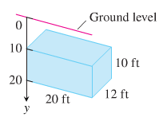The rectangular cistern (storage tank for rainwater) shown has its top 10 *ft* below ground level. The cistern, currently full, is to be emptied for inspection by pumping its contents to ground level.
40. How much work will it take to empty the cistern?
41. How long will it take a 1/-*hp* pump, rated at 275 *ft-lb/sec*, to pump the tank dry?
42. How long will it take the pump in part (b) to empty the tank hallway? ( It will be less than half the time required to empty the tank completely)
43. What are the answers to parts (a) through (c) in a location where water weighs 62.6 ? 62.59 ?
44. When a particle of mass *m* is at (*x*, 0), it is attracted toward the origin with a force whose magnitude is . If the particle starts from rest at *x* = *b* and is acted on by no other forces, find the work done on it by the time reaches *x* = *a*, 0 < *a* < *b*.
45. The strength of Earth’s gravitation field varies with the distance *r* from Earth’s center, and the magnitude of the gravitational force experienced by a satellite of mass *m* during and after launch is



Here,  is Earth’s mass,  is the universal gravitational constant, and *r* is measured in meters. The work it takes to lift a 1000-*kg* satellite from Earth’s surface to a circular orbit 35,780 *km* above Earth’s center is therefore given by the integral



Evaluate the integral. The lower limit of integration is Earth’s radius in meters at the launch site. (This calculation does not take into account energy spend lifting the launch vehicle or energy spent bringing the satellite to orbit velocity.)

1. You drove an 800-*gal* truck from the base of Mt. Washington to the summit and discovered on arrival that the tank was only half full. You started with a full tank, climbed at a steady rate, and accomplished the 4750*-ft* elevation change in 50 minutes.

Assuming that the water leaked out at a steady rate, how much work was spent in carrying the water to the top? Do not count the work done in getting yourself and the truck there. Water weighs 8- *lb*./*gal*.

1. A cylindrical water tank has height 8 *m* and radius 2 *m*

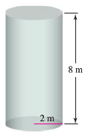

1. If the tank is full of water, how much work is required to pump the water to the level of the top of the tank and out of the tank?
2. Is it true it takes half as much work to pump the water out of the tank when it is half full as when it is full? Explain.
3. A water tank is shaped like an inverted cone with height 6 *m* and base radius 1.5 *m*.
4. If the tank is full of water, how much work is required to pump the water to the level of the top of the tank and out of the tank?
5. Is it true it takes half as much work to pump the water out of the tank when it is half full as when it is full? Explain

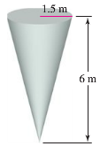

1. A spherical water tank with an inner radius of 8 *m* has its lowest point 2 *m* above the ground. It is filled by a pipe that feed the tank at its lowest point.4

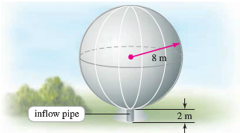

1. Neglecting the volume of the inflow pipe, how much work is required to fill the tank if it is initially empty?
2. Now assume that the inflow pipe feeds the tank at the top of the tank. Neglecting the volume of the inflow pipe, how much work is required to fill the tank if it is initially empty?
3. A large vertical dam in the shape of a symmetric trapezoid has a height of 30 *m*. a width of 20 *m*. at its base, and a width of 40 *m*. at the top. What is the total force on the face of the dam when the reservoir is full? 
4. A vertical gate in a dam has the shape of an isosceles trapezoid 8 *feet* across the top and 6 *feet* across the bottom. With a height of 5 *feet*. What is the fluid force on the gate if the top of the gate is 4 *feet* below the surface of the water?
5. Pumping water from a lake 15-*feet* below the bottom of the tank can fill the cylindrical tank shown here.



There are two ways to go about it. One is to pump the water through a hose attached to a valve in the bottom of the tank. The other is to attach the hose to the rim of the tank and let the water pour in. Which way will be faster? Give reason for answer.

1. A tank truck hauls milk in a 6*-feet* diameter horizontal right circular cylindrical tank. How must force does the milk exert on each end of the tank when the tank is half full?
2. A triangular plate, base 5 *feet*, height 6 *feet*, is submerged in water, vertex down, plane vertical, and 2 *feet* below the surface. Find the total force on one face of the plate.

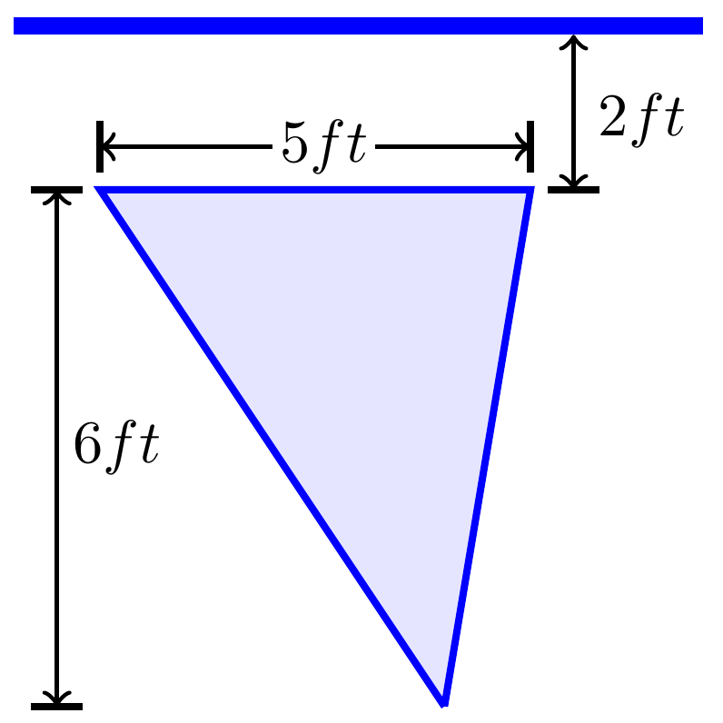

1. The vertical triangular plate shown here is the end plate of a trough full of water. What is the fluid force against the plate?

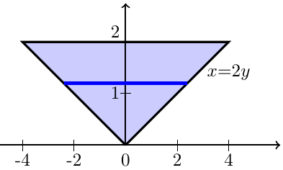

1. A cylindrical gasoline tank is placed so that the axis of the cylinder is horizontal. Find the fluid force on a circular end of the tank if the tank is ***half full*** assuming that the diameter is 3 *feet* and the gasoline weighs 42 *pounds* per *cubic* *foot*.
2. A cylindrical gasoline tank is placed so that the axis of the cylinder is horizontal. Find the fluid force on a circular end of the tank if the tank is ***full*** assuming that the diameter is 3 *feet* and the gasoline weighs 42 *pounds* per *cubic* *foot*.
3. A swimming pool is 20 *feet* wide, 40 *feet* long, 4 *feet* deep at one end, and 8 *feet* deep at the other end. The bottom is an inclined plane. Find the fluid force on each vertical wall.

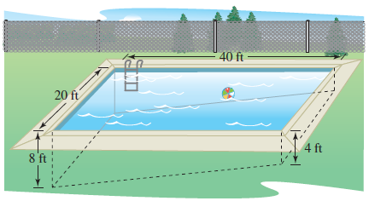

1. A swimming pool is 20 *m* leg long and 10 *m* wide, with a bottom that slopes uniformly from a depth of 1 *m* at one end to a depth of 2 *m* at the other end.

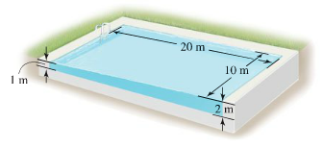

Assuming the pool is full, how much work is required to pump the water to a level 0.2 *m* above the top of the pool?

Find the total force on the face of the given dam

|  |  |  |  |
| --- | --- | --- | --- |
|  |  |  |  |
|  |  |  |  |
|  |  |  |  |
|  |  |  |  |
|  |  |  |  |

Find the fluid force on the vertical plate submerged in water

|  |  |  |  |
| --- | --- | --- | --- |
|  |  |  |  |
|  |  |  |  |
|  |  |  |  |
|  |  |  |  |

1. A rectangular plate of height ***h*** *feet* and base ***b*** *feet* is submerged vertically in a tank of fluid that weighs ***w*** *pounds per cubic foot*. The center is ***k*** *feet* below the surface of the fluid, where . Show that the fluid force on the surface of the plate is .
2. A circular plate of radius ***r*** *feet* is submerged vertically in a tank of fluid that weighs ***w*** *pounds per cubic foot*. The center of the circle is  *feet* below the surface of the fluid. Show that the fluid force on the surface of the plate is .
3. A large building shaped like a box is 50 *m* high with a face that is 80 *m* wide. A strong wind blows directly at the face of the building, exerting a pressure of  at the ground and increasing with height according to , where *y* is the height above the ground. Calculate the total force on the building, which is a meaure of the resistance that must be included in the design of the building.
4. Adiving pool that is 4 *m* deep full of water has a viewing window on one of its vertical walls. Find the force of the a square window, 0.5 *m* on side, with the lower edge of the window on the bottom of the pool.
5. Adiving pool that is 4 *m* deep full of water has a viewing window on one of its vertical walls. Find the force of the a square window, 0.5 *m* on side, with the lower edge of the window 1 *m* from the bottom of the pool.
6. Adiving pool that is 4 *m* deep full of water has a viewing window on one of its vertical walls. Find the force of the a circle window, with a radius of 0.5 *m*, tangent to the bottom of the pool.
7. A rigid body with a mass of 2 *kg* moves along a line due to a force that produces a position function , where *x* is measured in *meters* and *t* is measured in *seconds*. Find the work done during the first 5 *sec*. in two ways.
8. Note that ; then use Newton’s second law,  to evaluate the work integral , where  and  are the initial and final positions, repectively.
9. Change variables in the work integral and integrate with respect to *t*.
10. A plate shaped like an equilateral triangle 1 *m* on a side is placed on a vetical wall 1 *m* below the surface of a pool filled with water. On which plate in the figure is the force is greater

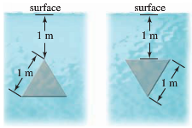

1. A square plate 1 *m* on a side is placed on a vetical wall 1 *m* below the surface of a pool filled with water. On which plate in the figure is the force is greater

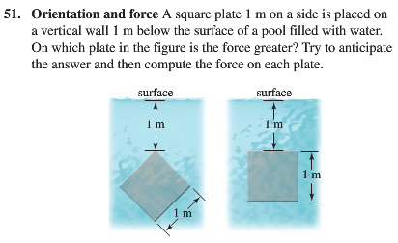

1. Water fills a tank in the shape of a right-circular cone with top radius 3 *m* and depth 4 *m*. How much work must be done (against gravity) to pump all the water out of the tank over the top edge of the tank?

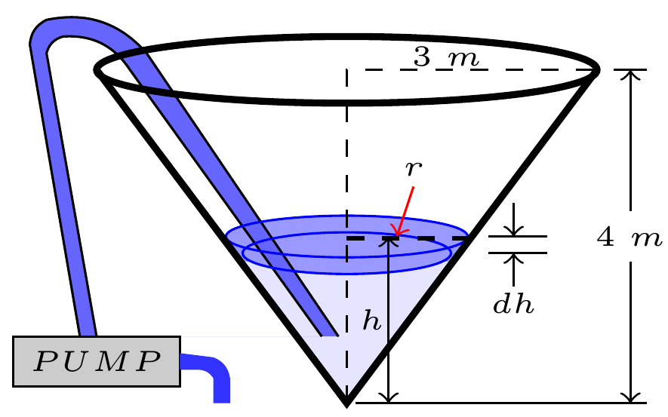

1. You are in charge of the evacuation and repair of the storage tank.

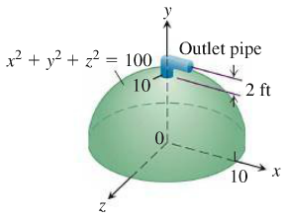

The tank is a hemisphere of radius 10 *feet* and is full of benzene weighing 56 . A firm you contacted says it can empty the tank for *ȼ* per foot-pound of work. Find the work required to empty the tank by pumping the benzene to an outlet 2 *feet* above the top of the tank. If you have $5,000 budget for the job, can you afford to hire the firm?

1. You decided to drill a well to increase a water supply. You have determined that a water tower will be necessary to provide the pressure needed for distribution

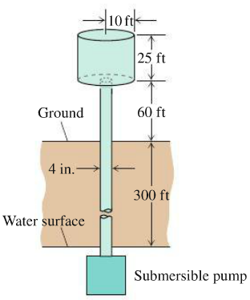

The water is to be pumped from a 300-*ft* well through a vertical 4-*in*. pipe into the base of a cylindrical tank 20 *feet* in diameter and 25 *feet* high. The base of the tank will be 60 *feet* above ground. The pump is a 3-*hp* pump, rated at . How long will it take to fill the tank the first time? (Include the time it takes to fill the pipe). Assume that water weighs .

1. Calculate the fluid force on one side of a right-triangular plate with edges 3 *feet*, 4 *feet*, and 5 *feet* if the plate sits at the bottom of the pool filled with water to a depth of 6 *feet* on its 3-*feet* edge and titlted at  to the bottom of the pool.

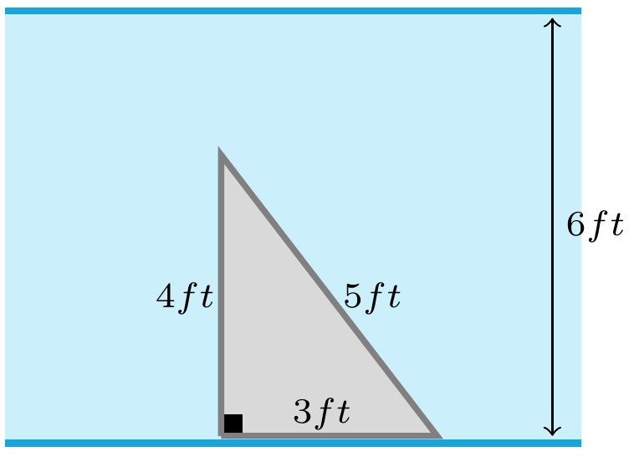 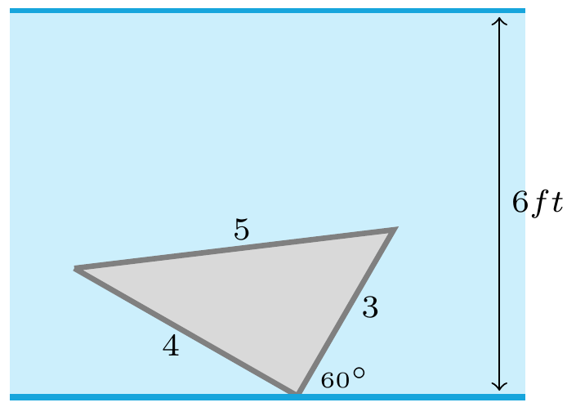

1. Two electrons *r* *meters* apart repel each other with a force of 
2. Suppose one electron is held fixed at the point  on the *x-*axis (units in *meters*). How much work does it take to move a second electron along *x-*axis from the point  to the origin?
3. Suppose one electron is held fixed at the point  and . How much work does it take to move a third electron along *x-*axis from the point  to ?
4. The isosceles triangular plate is submerged vertically 1 *feet* below the surface of a freshwater lake.

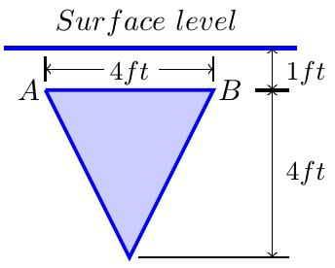

1. Find the fluid force against one face of the plate.
2. What would be the fluid force on one side of the plate if the water were seawater instead of freshwater?
3. The isosceles triangular plate is submerged vertically 3 *feet* above the surface of a freshwater lake. What force does the water exert on one face of the plate now?

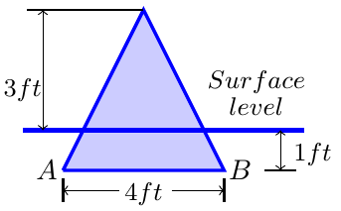

1. The cubical metal tank has parabolic gate held in place by bolts and designed to withstand a fluid force of 160 *lb*. without rupturing. The liquid you plan to store has a weight-density of .

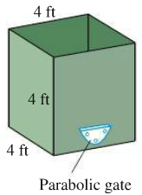 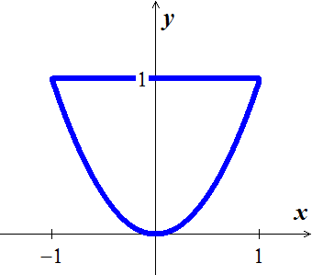

1. What is the fluid force on the gate when the liquid is 2 feet deep?
2. What is the maximum height to which the container can be filled without exceeding the gate’s design limitation?
3. The end plates of the trough were designed to withstand a fluid force of 6,667 *lb*.

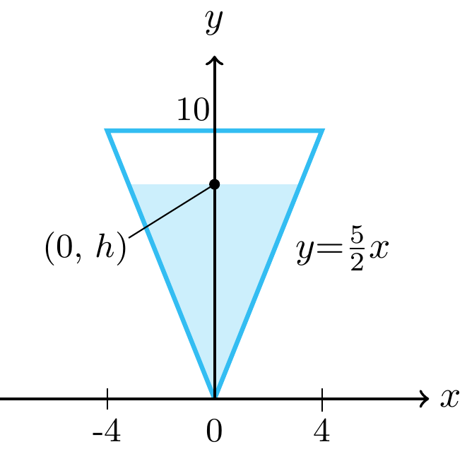 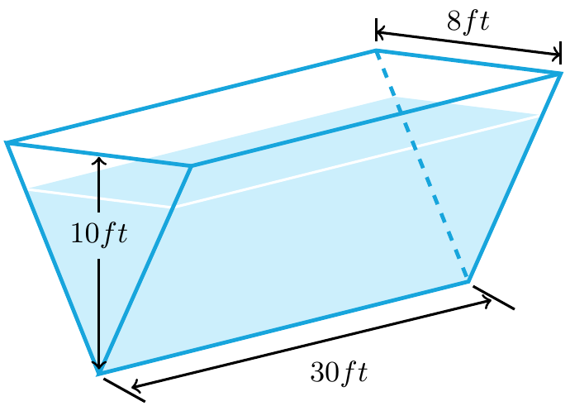

1. What is the value of *h*?
2. How many cubic feet of water can the tank hold without exceeding this limitation?
3. A circular observation window on a marine science ship has a radius of 1 *foot*, and the center of the window is 8 *feet* below water level. What is the fluid force on the window?

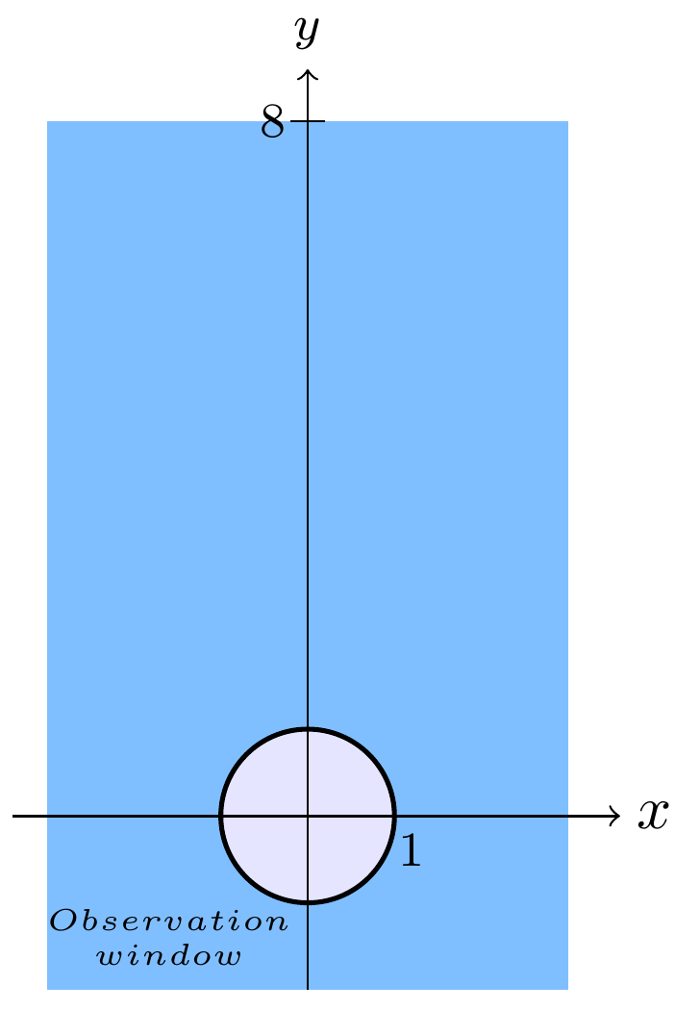

1. Water pours into the tank at the rate of . The tank’s cross-sections are 4-*ft*-diameter semicircles. One end of the tank is movable, but moving it to increase the volume compresses a spring. The spring constant is . If the end of the tank moves 5 feet against the spring, the water will drain out of a safety hole in the bottom at the rate of . Will the movable end reach the hole before the tank overflows?

